Feng Chia University

Electrical Engineering Fundamentals I Lab

Laboratory 8

Inductors and Capacitors R-L-C Circuit

Instructor: Prof. Shyan-Lung Lin

Student Name: 周嘉禾

Student ID: D1166506

Experiment Date:07/12/2023

1. Introduction
2. To be familiar with Source-Free Second Order Linear R-L-C Circuit
3. To be familiar with Constant Input Parallel R-L-C Circuit
4. Materials
   1. DC Power Supply
   2. Digital multimeter
   3. Waveform Generator
   4. Oscilloscope
   5. Devices
      1. DIP Switch
      2. Resistors: R = 51 Ω, 5.1 Ω

Capacitor: C = 1 µF

Inductor: L = 40 mH

* + 1. Resistors: R = 5.1 Ω, 1 kΩ

Capacitor: C = 0.1µF

Inductor: L = 1 mH

1. Circuit diagram

▲ Figure 1. Circuit of Experiment 8.a Source-Free Second Order Series R-L-C

Circuit

▲ Figure 2. Circuit of Experiment 8.b Step Response of a Second Order Parallel

R-L-C Circuit

1. Methods

Use Oscilloscope to observe the wave.

1. Experiments data

None

1. Results

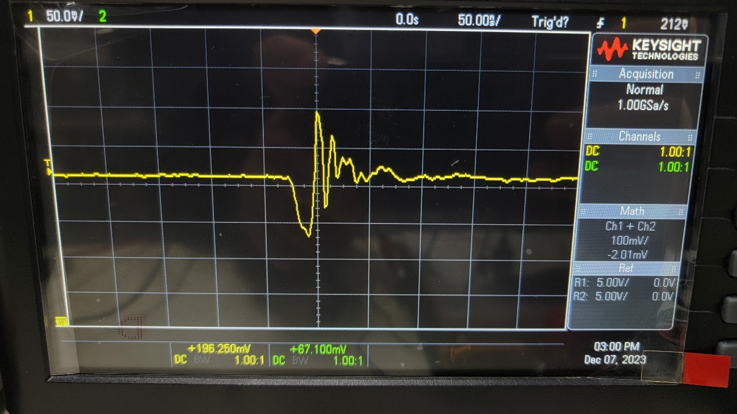

▲ Figure 3. Result of Experiment 8.a Step 1

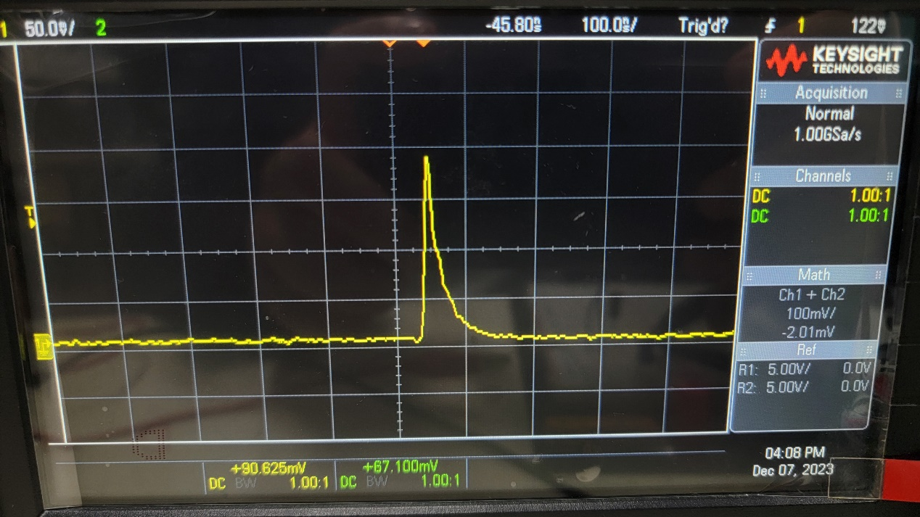

▲ Figure 4. Result of Experiment 8.a Step 2

▲ Figure 5. Result of Experiment 8.b

1. Discussion

Since resistor is not equal to 0, the graph will be underdamped.

1. Conclusion

With Oscilloscope, we can clearly observe the oscillation situation on resistor.